Task 4: SQL for Data Analysis

Objective: Use SQL queries to extract and analyze data from a database.

Tools: MySQL or PostgreSQL or SQLite

Deliverables: SQL queries in a SQL file + screenshots of output

Hints/Mini Guide:

a.Use SELECT, WHERE, ORDER BY, GROUP BY

b.Use JOINS (INNER, LEFT, RIGHT)

c.Write subqueries

d.Use aggregate functions (SUM, AVG)

e.Create views for analysis

f.Optimize queries with indexes

Dataset: Ecommerce_SQL_Database( or any data set of your choice)

Outcome: Learn to manipulate and query structured data using SQL.

Creating the connection in MYSql to export the data

Database created

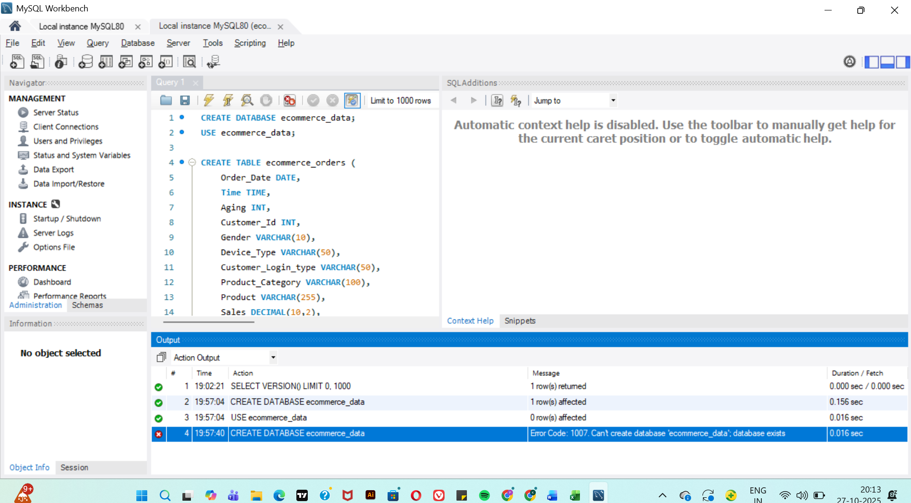

Table created   
  
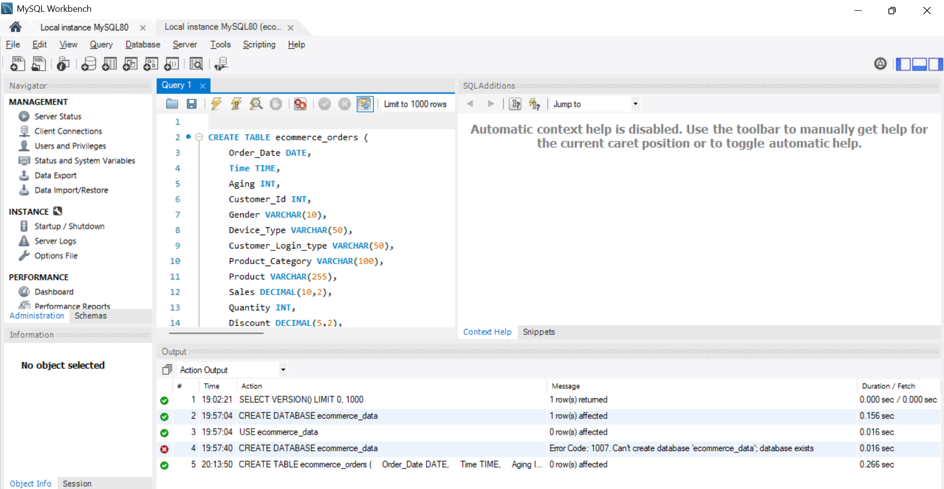

In MySQL Workbench top menu →  
**Server → Data Import Wizard**

**Choose:  
Import from Self-Contained File → browse to your E-commerce Dataset.csv**

**Choose your schema: ecommerce_data**

**Target Table: ecommerce_orders**

**Match columns automatically → click Next, then Finish.**

**Successfully imported the excel**

**To check the connection and the table creation   
  
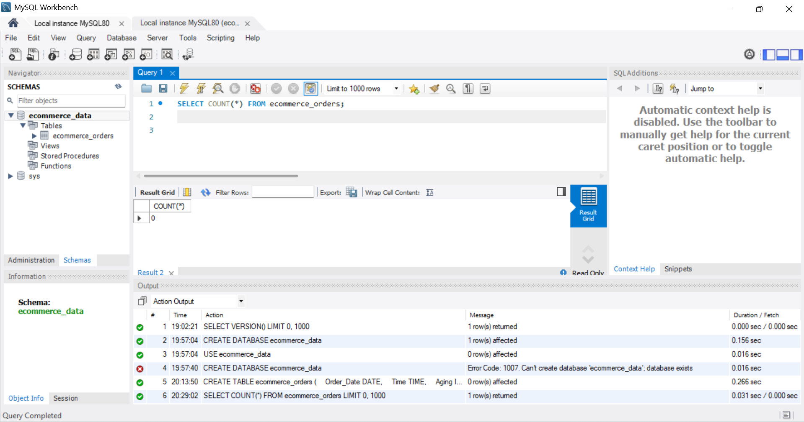**

Task (a): Use SELECT, WHERE, ORDER BY, GROUP BY

SELECT * FROM ecommerce_orders LIMIT 10;

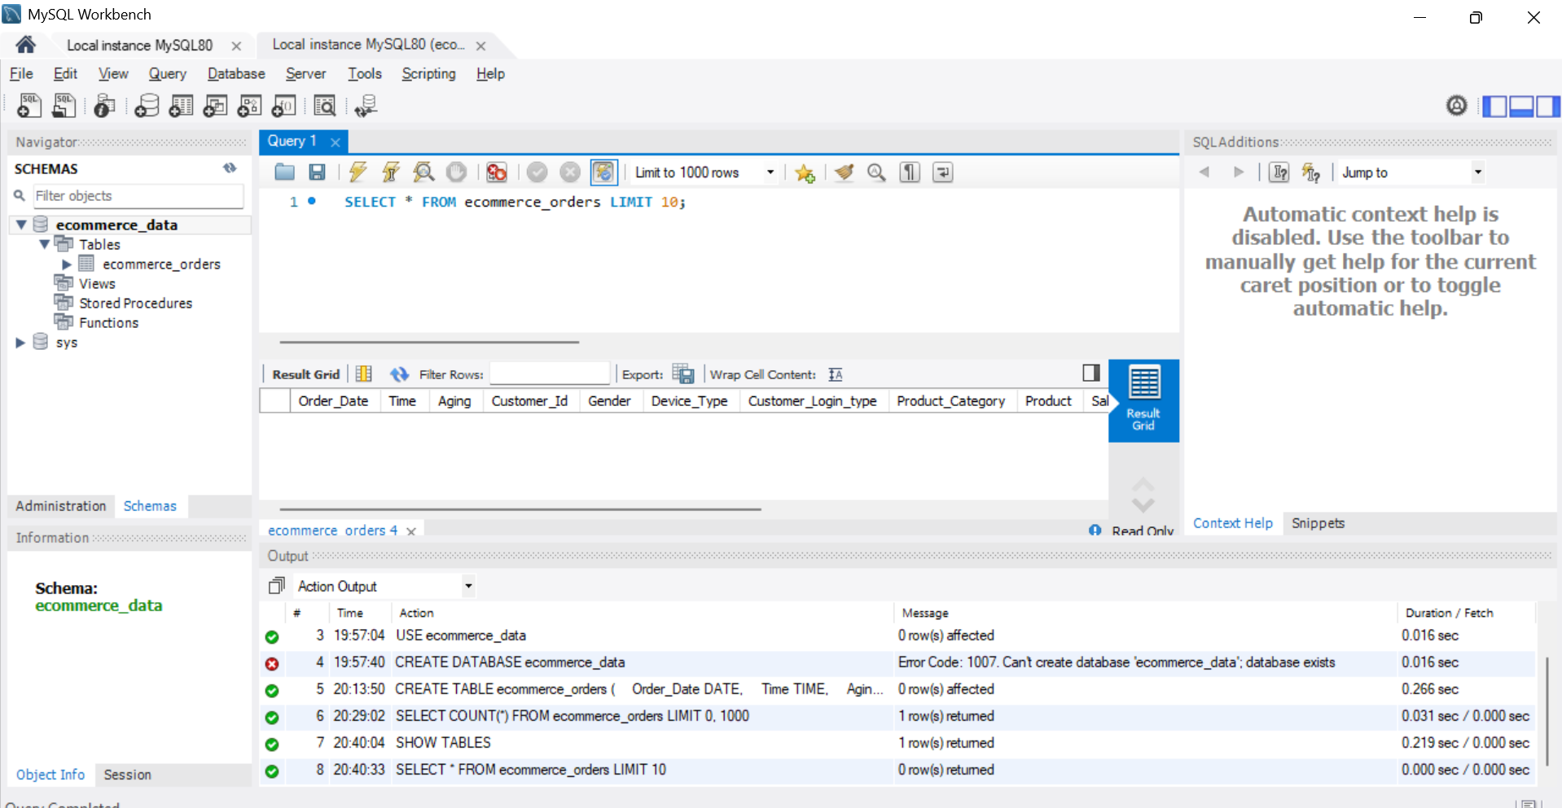

Finding top selling products

SELECT

Product_Category,

SUM(Quantity) AS Total_Quantity,

SUM(Sales) AS Total_Sales,

SUM(Profit) AS Total_Profit

FROM ecommerce_orders

GROUP BY Product_Category

ORDER BY Total_Sales DESC;

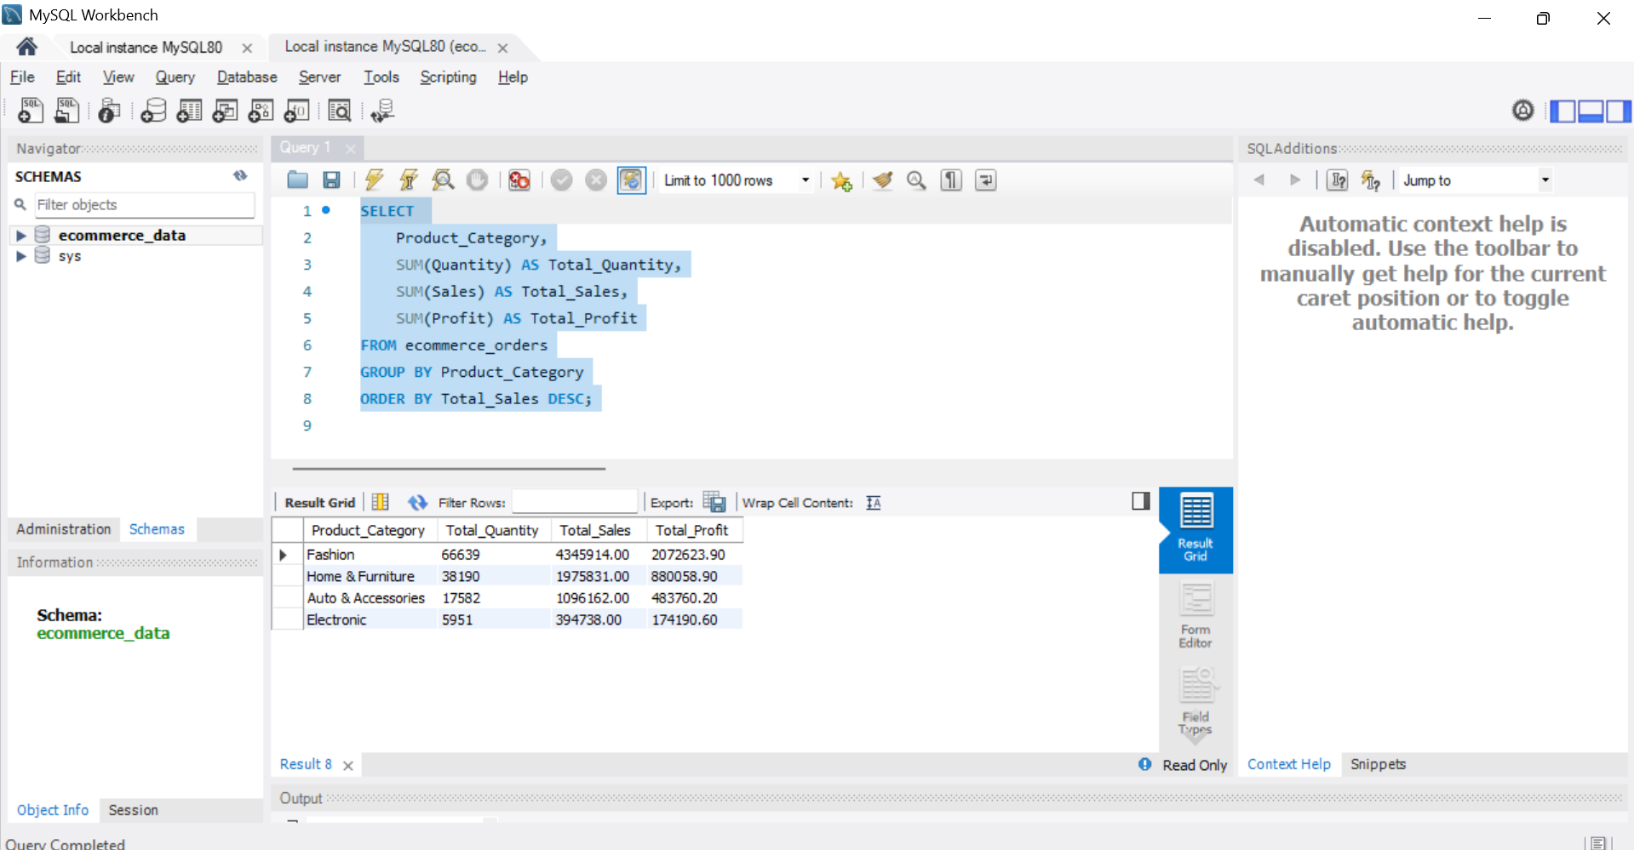

**Filter by age**

SELECT *

FROM ecommerce_orders

WHERE aging = 10

ORDER BY Order_Date DESC;

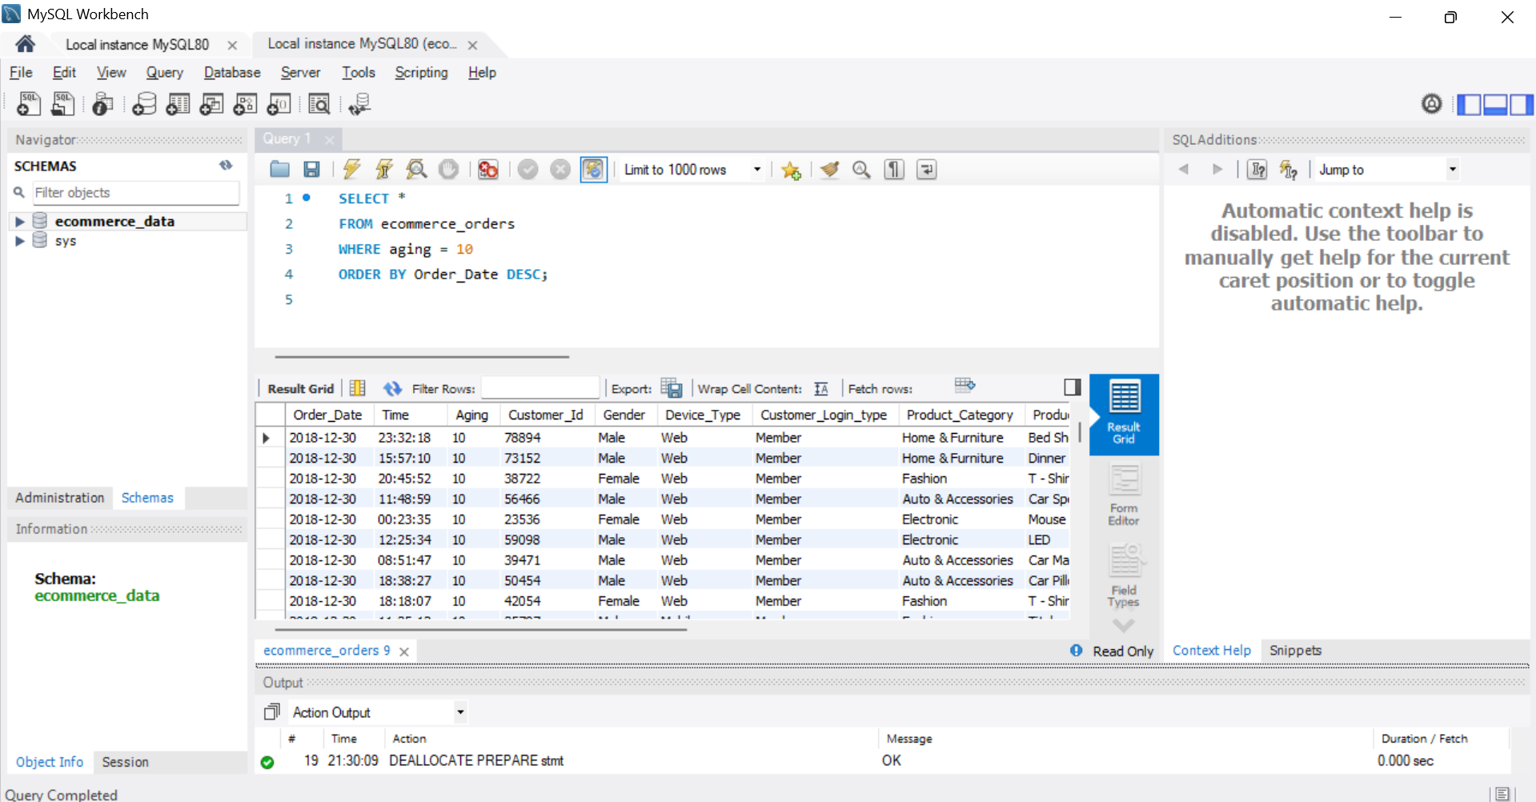

Task (b): Use JOINS (INNER, LEFT, RIGHT)

SELF JOIN

SELECT a.Customer_Id, a.Product AS Product_1, b.Product AS Product_2, a.Product_Category

FROM ecommerce_orders a

INNER JOIN ecommerce_orders b

ON a.Customer_Id = b.Customer_Id

AND a.Product_Category = b.Product_Category

AND a.Product <> b.Product

LIMIT 10;

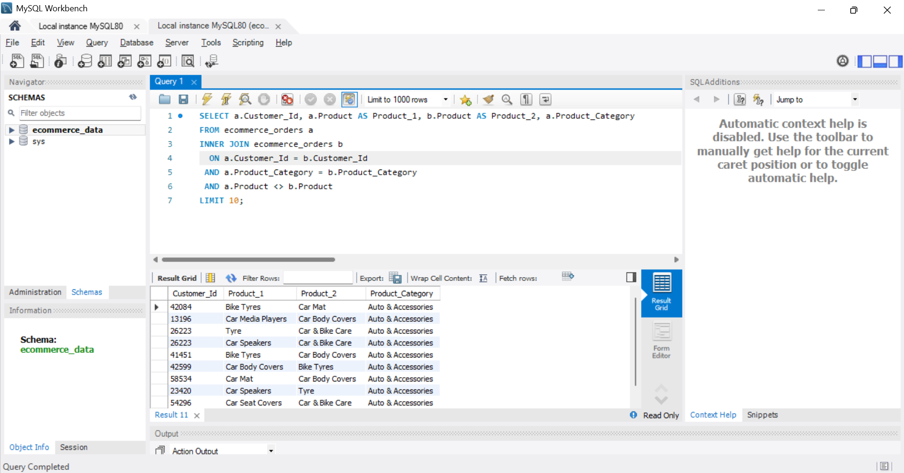

**Join with a Derived Table**

Join with a summary (created on the fly):

SELECT e.Customer_Id, e.Product_Category, e.Sales, s.Total_Sales

FROM ecommerce_orders e

INNER JOIN (

SELECT Customer_Id, SUM(Sales) AS Total_Sales

FROM ecommerce_orders

GROUP BY Customer_Id

) AS s

ON e.Customer_Id = s.Customer_Id

LIMIT 10;

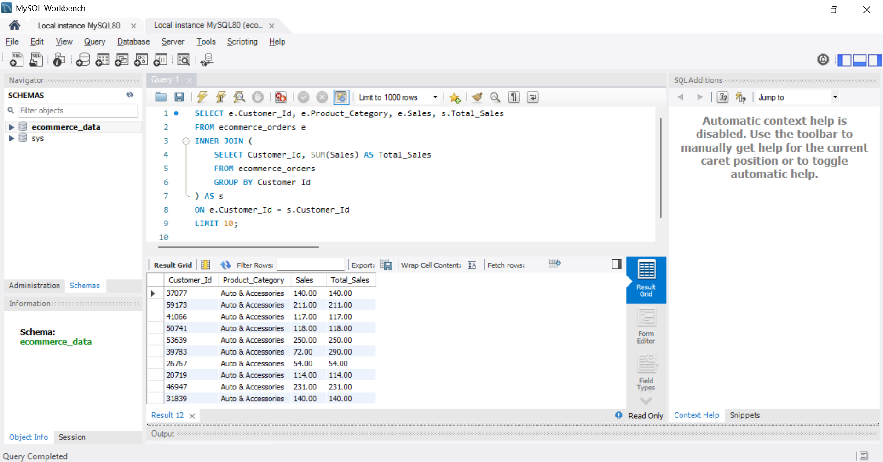

c.Write subqueries

SELECT Customer_Id, SUM(Sales) AS TotalSales

FROM ecommerce_orders

GROUP BY Customer_Id

HAVING TotalSales > (

SELECT AVG(Sales) FROM ecommerce_orders

);

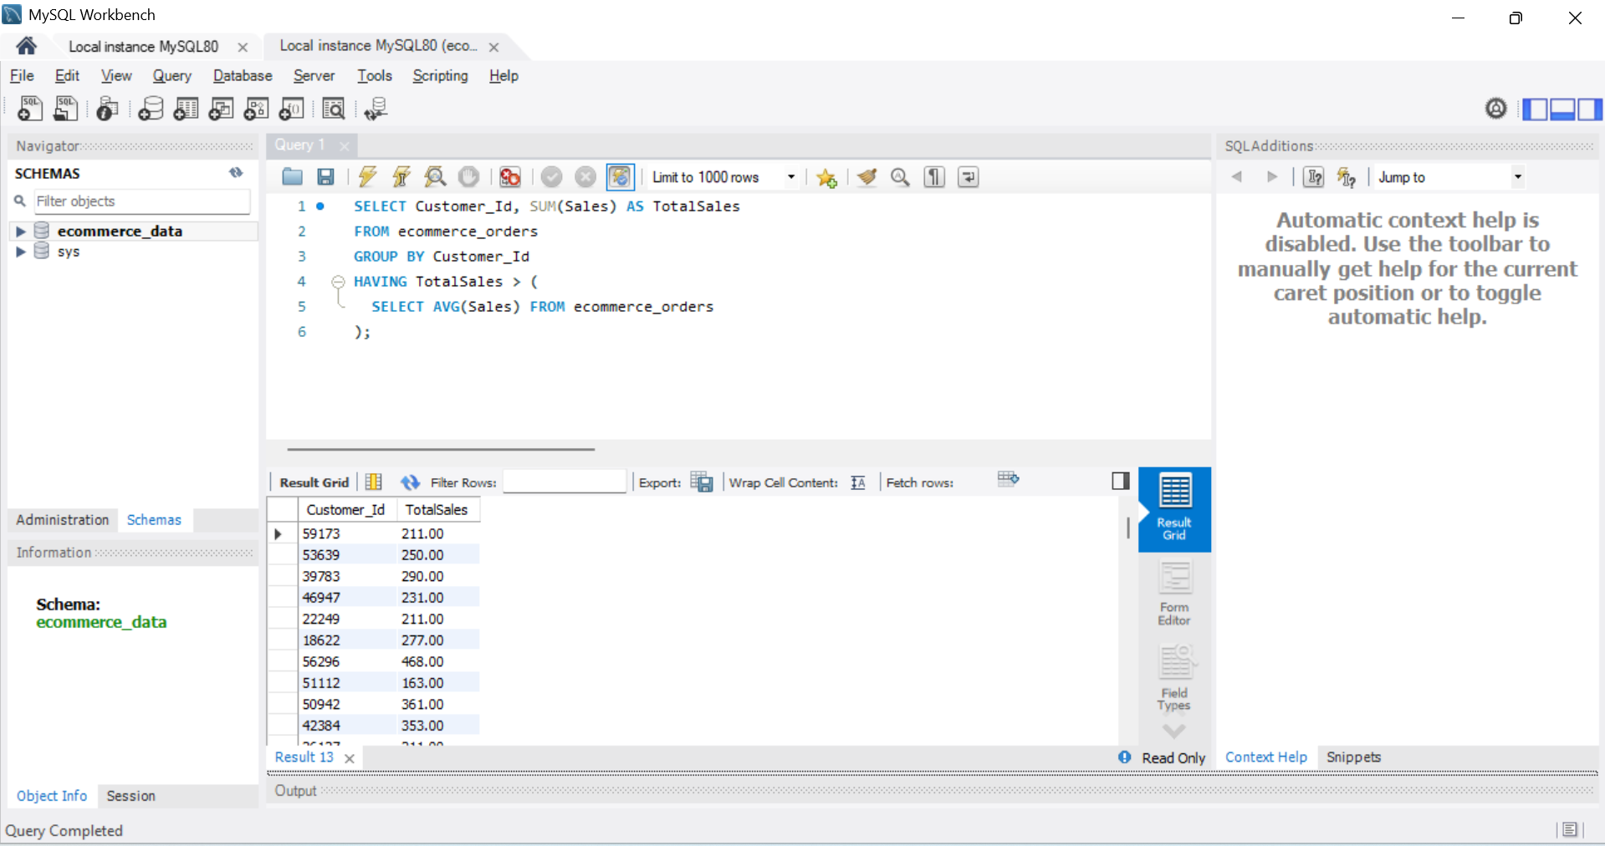

d.Use aggregate functions (SUM, AVG)

SELECT Payment_method, SUM(Sales) AS Total_Sales, AVG(Profit) AS Avg_Profit

FROM ecommerce_orders

GROUP BY Payment_method;

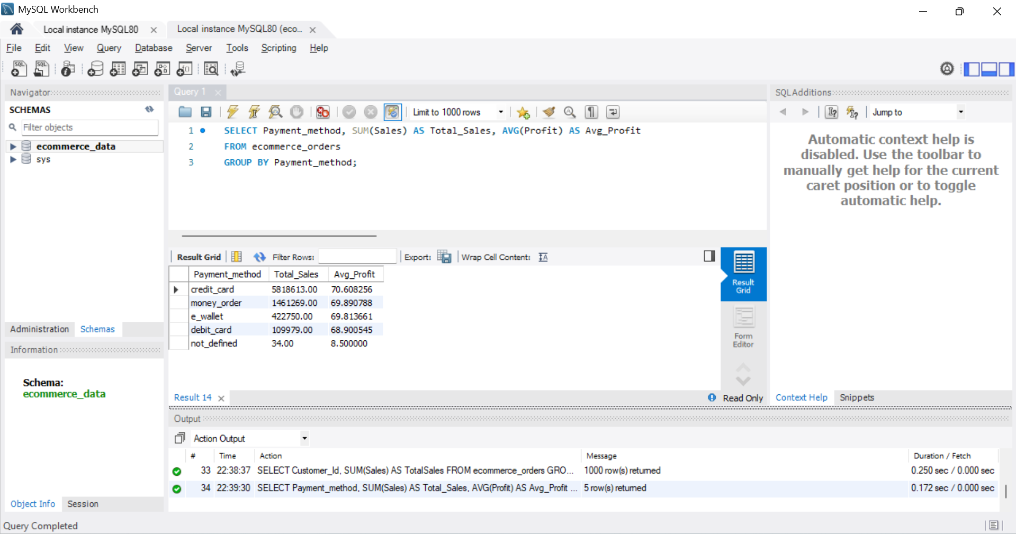

e.Create views for analysis

CREATE VIEW profit_by_category AS

SELECT Product_Category,

SUM(Sales) AS Total_Sales,

SUM(Profit) AS Total_Profit,

AVG(Discount) AS Avg_Discount

FROM ecommerce_orders

GROUP BY Product_Category;

SELECT * FROM profit_by_category ORDER BY Total_Profit DESC;

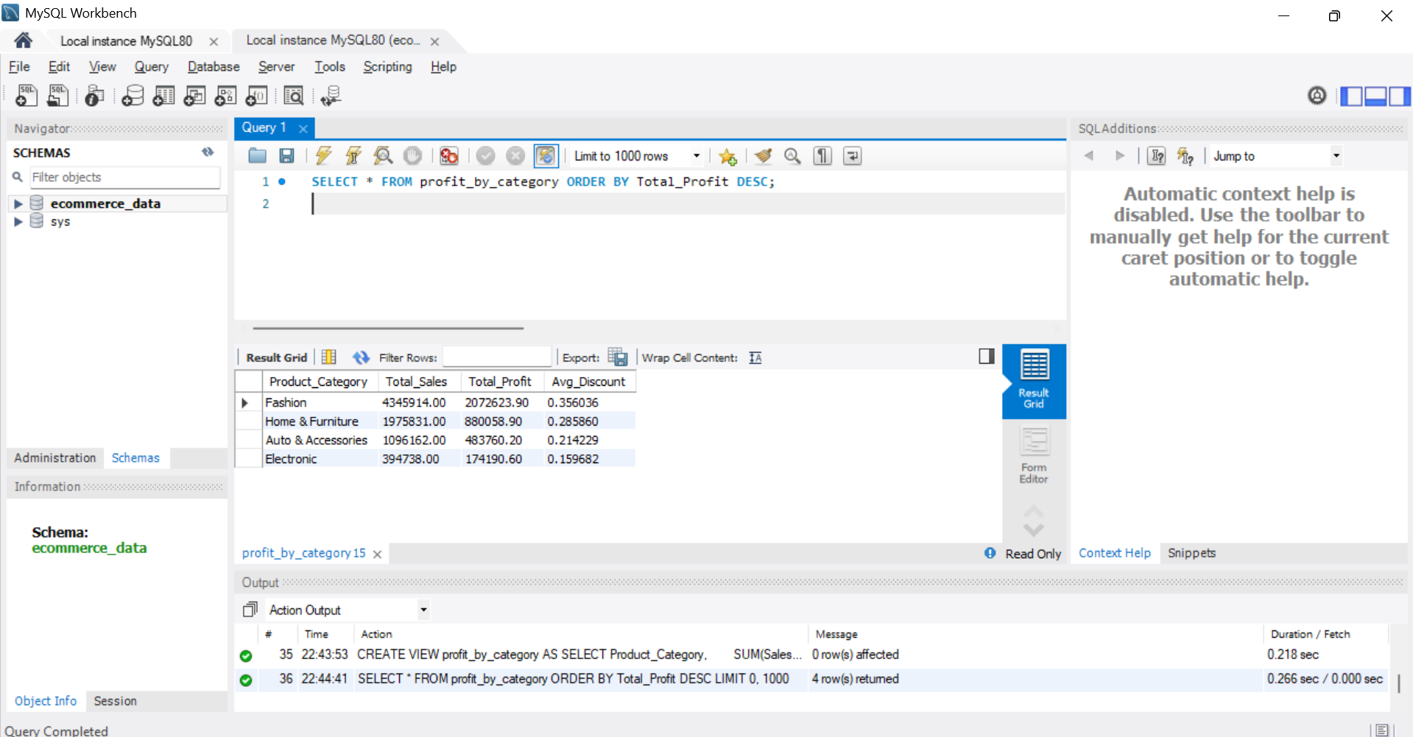

f.Optimize queries with indexes

CREATE INDEX idx_customer_id ON ecommerce_orders (Customer_Id);

CREATE INDEX idx_product_category ON ecommerce_orders (Product_Category);

CREATE INDEX idx_order_priority ON ecommerce_orders (Order_Priority);

